**Unlocking Insights into the Global Air Transportation Network with Tableau**

**1.Introduction: 1.1. Overview** :

This Global Air Transportation Network dataset is a comprehensive collection of information on airports, airlines and their routes. It contains information such as names, cities, countries, codes (IATA and ICAO) longitudes, latitudes and altitudes of airports across the world with detailed time zone and daylight saving time data. Additionally, this includes information about airlines including their IDs, name aliases, IATA and ICAO codes, callsigns country of origin and active/inactive status. Similarly, it also covers route details such as airline sources to destination airports along with essential details like codeshare stakeholder if any stops required during this journey along with the type of aircraft being used for that particular journey. This dataset has been compiled through meticulous labor by researchers all over the world to give you a comprehensive detail into air transportation networks from around the globe. **1.2.Purpose:** The Global air Transportation Network with tableau airports,airlines,and routes dataset is provide to industry with accurate up-to -date information on the worldwide air transportation network. Ultimately the bussiness requirement of the dataset is to enable stakeholders in the aviation industry to gain advantage by making data-version.

**2. Problem Definition& Design Thinking 2.1.Empathy map**

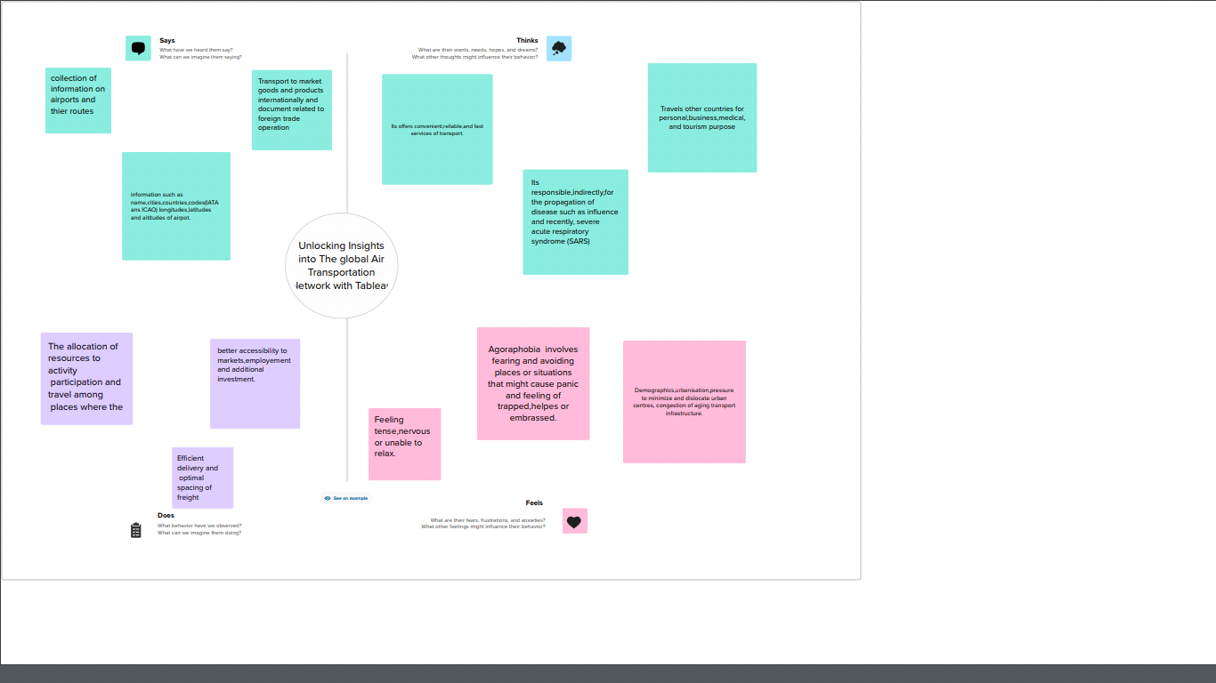

**2.2 Ideation & Brainstorming Map**

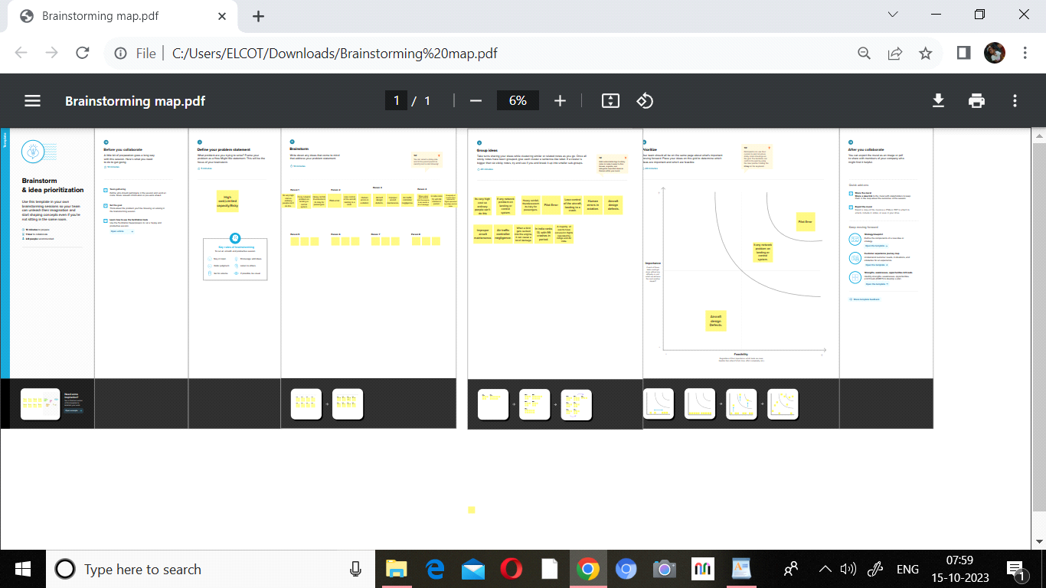

**3. Result**

**3.1. World map showing details of all airports within a country**

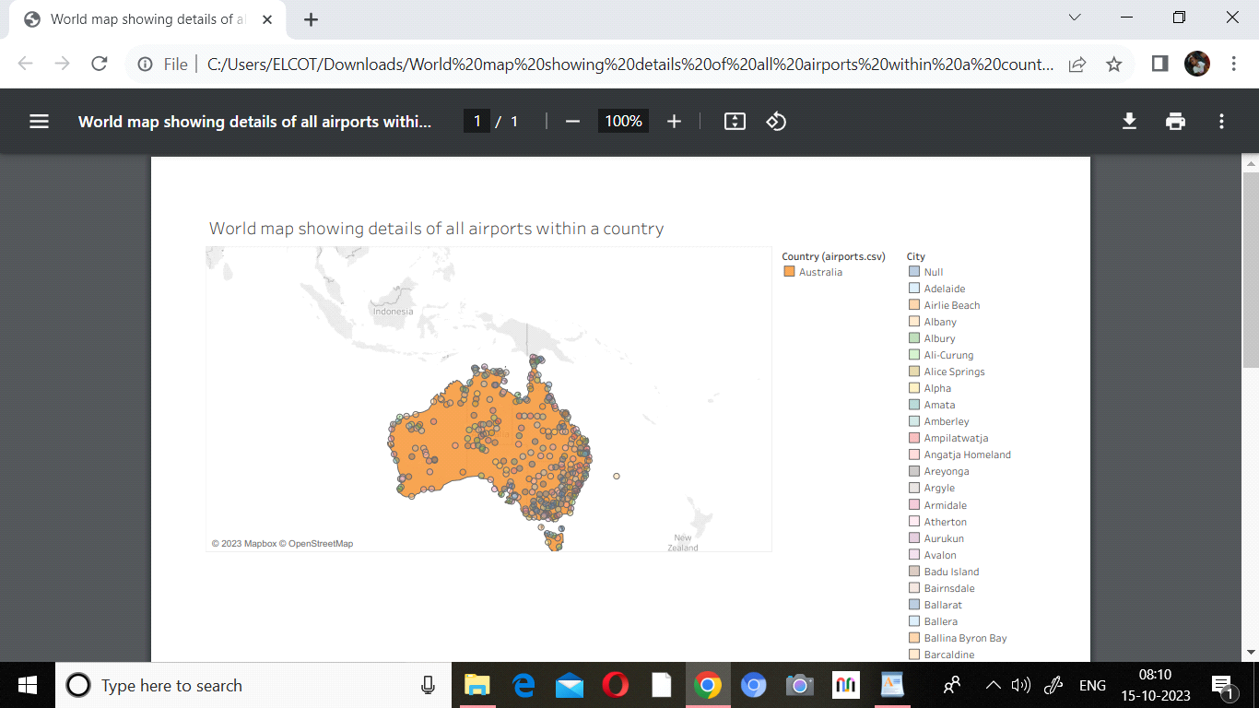

**This world map showing the all airports within a country .The world map within a country to find the airports and this map shows the Belgium international aiports.Then different colours are defined into the country internationanl areas. Then contains the ICAO code,Altitude.city, and IATA and Longitudes**

**3.2. Article at higher altitude within a world**

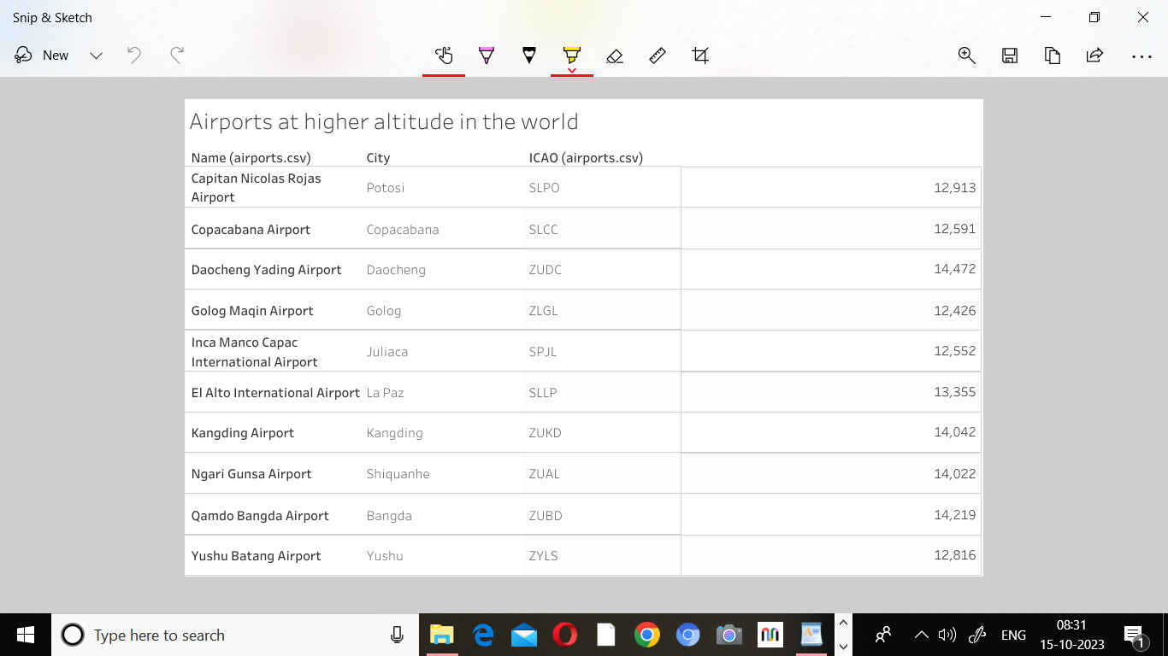

**This table consists a Airport at higher Altitude in the world.This sheet is top 10 airports name, their city names and ICAO code Then results are higher altitude in the world.**

**3.3.Airlines within a country**

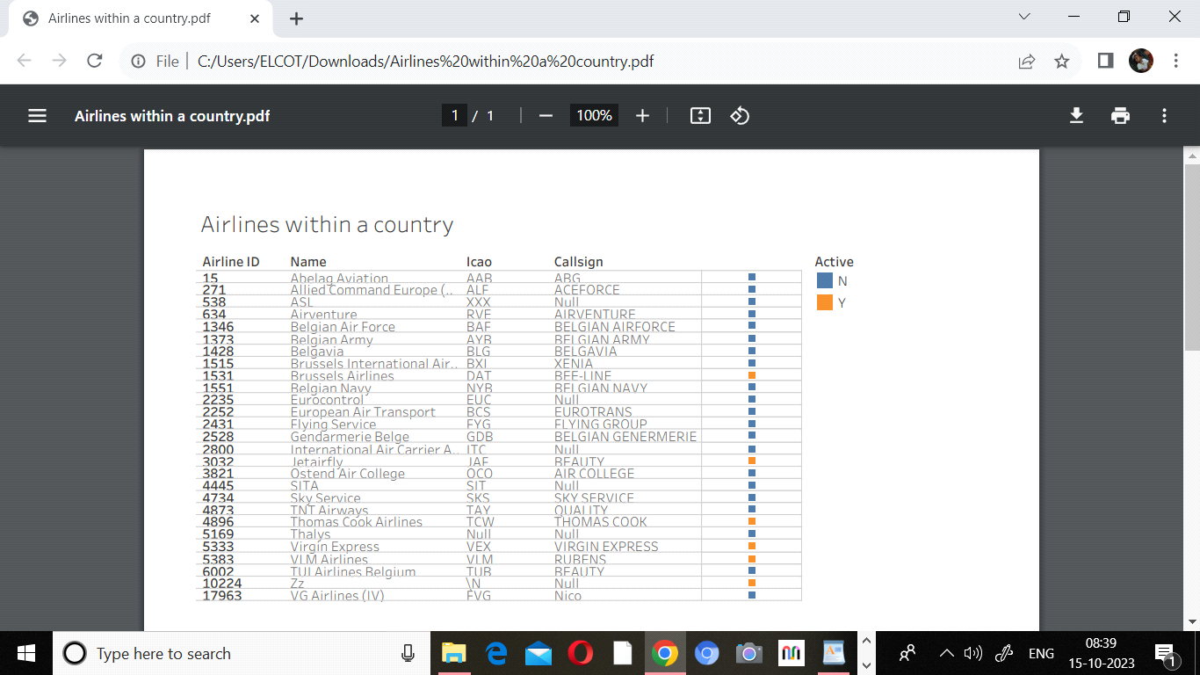

**Airlines within the a country is a easily to find the airline ID .The airlines are active and deactive the orange colures are represented to the active airline and blue colours**

**3.4 Number of flights pro**

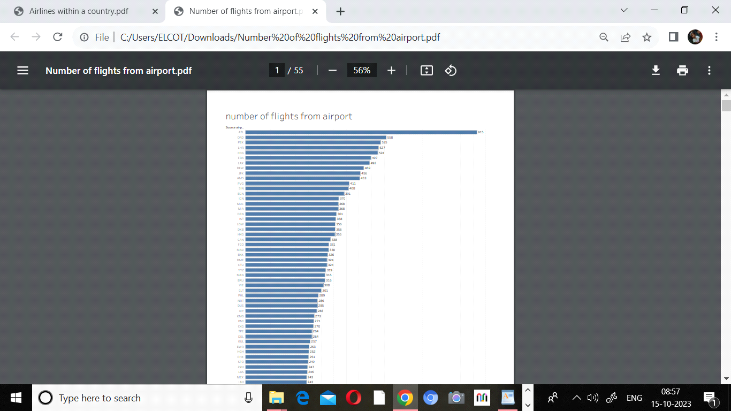

**This page is consists of the number of flights from the airport. Then source of the airport to graph the highest to lowest number of flights from airport in countries. 3.5.Airports at higher altitude in the country**

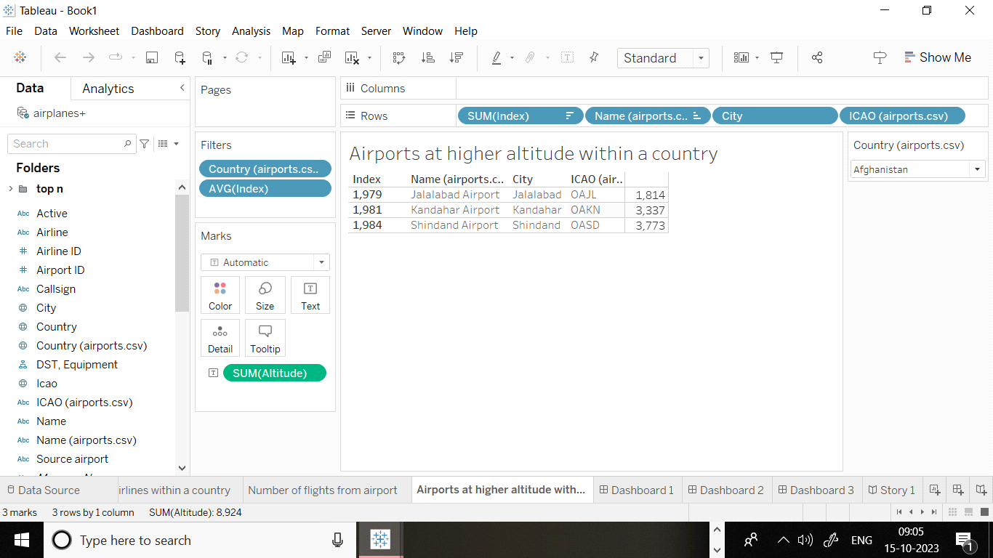

**Airports at higher altitude within the country is identified to the top 3 airports name, and the city,ICAO codes.**

**4. Advantages :**

**Undoubtedly, one of the most advantageous features offered by air transport is its speedy Air transport is the only means of transportation that does not support physical limits. Disadvantages**

**Although the advantages of air transport are very attractive and define a totally unbeatable type of service, it is also possible to define a series of disadvantages that should be analyzed to determine whether air transport is appropriate or whether it is preferable to consider other types of transport, such as sea transport.**

**5. Application**

**Data analysis provide a useful information to support thier decision makind process. Unlocking insights into the Global Air Transportation network with Tableau is applicant to the details of the of Airports.Airlines,routes and Airplanes to the countries.**

**6. Conclusion**

**World map showing details of all airports within a country**

**This world map showing the all airports within a country .The world map within a country to find the airports and this map shows the Belgium international aiports.Then different colours are defined into the country internationanl areas. Then contains the ICAO code,Altitude.city, and IATA and Longitudes**

**Article at higher altitude within a world**

**This table consists a Airport at higher Altitude in the world.This sheet is top 10 airports name, their city names and ICAO code Then results are higher altitude in the world.**

**Airlines within a country**

**Airlines within the a country is a easily to find the airline ID .The airlines are active and deactive the orange colures are represented to the active airline and blue colours**

**Number of flights pro**

**This page is consists of the number of flights from the airport. Then source of the airport Airports at higher altitude in the country**

**Airports at higher altitude within the country is identified to the top 3 airports name, and the city,ICAO codes.**